Capstone Project Assessment

Project 5 – Policy, Compliance and Summary

EXECUTIVE SUMMARY

Introduction
The purpose of this project is to consolidate the security architecture, identity management controls, Red Team findings, and Blue Team defensive mechanisms developed during Projects 1–4. As AI agents increasingly interact with APIs, databases, external tools and sensitive organizational information, securing their identities and credentials becomes essential.
This project establishes an AI Identity Security Policy, maps implemented security controls to recognized frameworks, identifies remaining compliance gaps and proposes recommendations to improve the organization's AI security posture.

Project Objectives
The primary objectives are:
- Establish an AI Identity Security Policy.
- Define identity lifecycle management requirements.
- Establish credential governance and key rotation standards.
- Develop an Incident Response Playbook.
- Map security controls to NIST AI RMF.
- Map Red Team attacks and Blue Team controls to OWASP LLM Top 10.
- Establish a GitHub portfolio containing all five project folders.
- Prepare an executive presentation and risk-based recommendations.

Project Deliverables
Deliverable | Description
AI Security Policy | Formal identity and credential security policy
Compliance Mapping | NIST AI RMF and OWASP mapping
GitHub Portfolio | Five project folders with documentation
Final Presentation | 20-minute capstone presentation
Executive Walkthrough | Risk assessment and recommendations

1. AI IDENTITY SECURITY POLICY

Table of Contents
- Identity Lifecycle
- Credential Governance
- Incident Response Playbook

Purpose
This policy defines the minimum security requirements for managing AI agent identities, credentials, authentication, authorization and incident response.
It ensures that AI agents operate securely, have appropriate access permissions and cannot perform unauthorized activities.

Scope
This policy applies to:
- AI agents and autonomous workloads.
- AI orchestration services.
- API integrations.
- Retrieval-Augmented Generation (RAG) systems.
- Model Context Protocol (MCP) tools.
- Authentication and authorization services.
- Developers, administrators and security teams.

Policy Principles
The organization follows these principles:
- Least Privilege.
- Zero Trust.
- Unique Agent Identity.
- Credential Protection.
- Secure Communication.
- Continuous Monitoring.
- Accountability and Auditability.

1.1 Identity Lifecycle Management
Purpose: This section defines how AI agent identities are provisioned, reviewed, rotated, and decommissioned across their lifecycle.

1.1.1 Identity Provisioning
- Every AI agent (M2M application) must be registered in Auth0 with a unique Client ID before it can obtain a token.
- Each agent is assigned the minimum scopes required for its function (least privilege), approved by the Security team before activation.
- Provisioning requests must document: agent owner, business justification, requested scopes, and expected lifetime (temporary vs. permanent).

1.1.2 Identity Review
- All agent identities are reviewed quarterly (every 90 days) by the Security team to confirm the assigned scopes still match the agent’s active function.
- Any agent inactive for 30 consecutive days is flagged for deactivation review.
- Review findings are logged with: reviewer, date, scopes confirmed/removed, and next review date.

1.1.3 Credential Rotation
- Client secrets and M2M credentials are rotated on a maximum 90-day schedule (see Section 2).
- Signing keys used for inter-agent message authentication (Project 4) are rotated every 180 days or immediately upon suspected compromise.

1.1.4 Identity Decommissioning
- When an agent is retired, its Auth0 application is deactivated within 24 hours and its Client Secret revoked immediately.
- All scopes and API authorizations tied to the agent are removed.
- A decommissioning record is kept for 12 months for audit purposes.

1.1.5 Identity Lifecycle Timelines
Activity | Required Timeline
Standard access review | Every 90 days
Privileged access review | Every 30 days
Static API key rotation | Maximum 90 days
Critical compromise containment | Immediately target within 15 minutes where feasible
Approved identity retirement | Within one business day

1.2 Credential Governance
Purpose: Credential governance ensures that AI agents use secure authentication mechanisms, and that credentials cannot be easily stolen, reused or misused.

1.2.1 API Key / Secret Rotation Schedule
- All agent credentials (Client Secrets, M2M tokens’ signing keys) must be rotated at a maximum interval of 90 days.
- Access tokens issued to agents are short-lived (≤300 seconds per Project 4 hardening) to minimize exposure from a leaked token.

1.2.2 Prohibition on Long-Lived Credentials
- Agents must not use static, non-expiring API keys for authentication.
- All agent-to-API authentication uses OAuth 2.0 Client Credentials grant with short-lived access tokens, never hardcoded long-lived secrets.
- Any exception requires written Security sign-off and a compensating control (e.g., IP allowlisting).

1.2.3 Secrets Management Standards
- Client Secrets and signing keys are stored only in a secrets manager (e.g., environment variables loaded from a vault), never committed to source control.
- .env files are excluded via .gitignore in every project repository.
- Secrets are never logged, printed in plaintext to terminal output used for evidence, or included in screenshots submitted for this capstone (redact before capture).

1.2.4 Prohibited Practices
The following activities are prohibited:
- Sharing agent identities.
- Hardcoding credentials.
- Exposing JWT tokens.
- Using unnecessary long-lived credentials.
- Accepting unverified orchestrator messages.
- Giving AI agents unrestricted administrative access.
- Using model-generated instructions as authorization decisions.

1.3 Incident Response Playbook
This playbook defines how security teams respond to incidents involving AI agent identities, leaked credentials and prompt injection attacks. The incident response process consists of:
- Detection.
- Identification.
- Containment.
- Evidence Preservation.
- Notification.
- Recovery.

1.3.1 Scenario A – Leaked LLM API Key
Phase | Action
Detection | Anomaly detector (Project 4, Task 4) fires a VOLUME_SPIKE or EXPIRED_TOKEN_REUSE alert; or the key appears in a public GitHub scan.
Containment | Immediately revoke the leaked key/Client Secret in the Auth0 dashboard. Rotate to a new secret.
Evidence Preservation | Export Auth0 logs for the affected Client ID covering the suspected exposure window; save anomaly detector alert output with timestamps.
Notification | Notify the Security lead within 1 hour of confirmed leak; notify affected system owners within 4 hours.
Recovery | Issue new credentials to the legitimate agent; confirm no privileged actions were taken using the old key by reviewing logs; update secrets manager.

1.3.2 Scenario B – Compromised AI Agent Identity
Phase | Action
Detection | Signature verification failures (Project 4, Task 2) logged repeatedly for one agent ID, or a SCOPE_CHANGE anomaly alert fires.
Containment | Disable the compromised agent’s Client ID in Auth0 immediately; block its signing key from the trusted key list.
Evidence Preservation | Capture the failed signature verification logs and the specific tampered message payload.
Notification | Notify Security lead within 1 hour; notify the agent’s business owner within 4 hours.
Recovery | Issue a new Ed25519 key pair and new Client credentials; re-provision the agent under the Identity Lifecycle process (Section 1.1); conduct root-cause review before reactivation.

1.3.3 Scenario C – Successful Prompt Injection Leading to Data Exfiltration
Phase | Action
Detection | Output guardrail (Project 4, Task 1) logs a redaction event, or a user/monitoring system reports unexpected data in a model response.
Containment | Temporarily disable the affected agent or conversation flow; tighten the input guardrail pattern list to block the specific payload pattern used.
Evidence Preservation | Save the full payload (verbatim), the model’s full response, and the guardrail log showing whether it fired or was bypassed.
Notification | Notify Security lead within 1 hour; notify Data Protection/Compliance within 4 hours if any real user data was exposed.
Recovery | Patch the guardrail rule set to cover the bypass technique; re-run the full Project 3 attack suite against the patched system before returning the agent to production.

1.3.4 Incident Response Summary
Scenario | Main Threat | Primary Containment
Leaked API Key | Credential exposure | Revoke and replace key
Compromised Agent | Identity compromise | Disable identity and revoke tokens
Prompt Injection | Unauthorized data access | Stop agent and quarantine malicious content

2. COMPLIANCE MAPPING

2.1 NIST AI Risk Management Framework
The NIST AI RMF provides four primary functions:
- GOVERN: Establish policies, accountability and organizational responsibilities.
- MAP: Understand the AI system, its context, dependencies and potential risks.
- MEASURE: Evaluate and measure AI security risks.
- MANAGE: Apply security controls and manage identified risks.

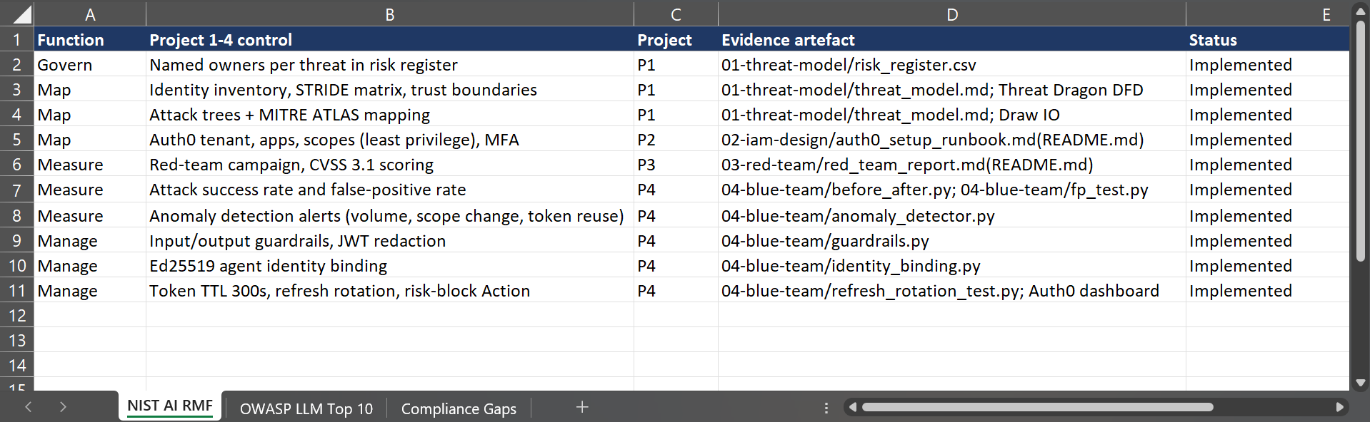Figure 1: NIST AI RMF tab showing all four functions (Govern, Map, Measure, Manage) mapped with evidence cited.

2.2 OWASP LLM Top 10 Mapping
The assessment requests the following OWASP 2025 categories.
LLM01 – Prompt Injection
LLM06 – Excessive Agency
LLM07 – System Prompt Leakage
LLM09 – Misinformation
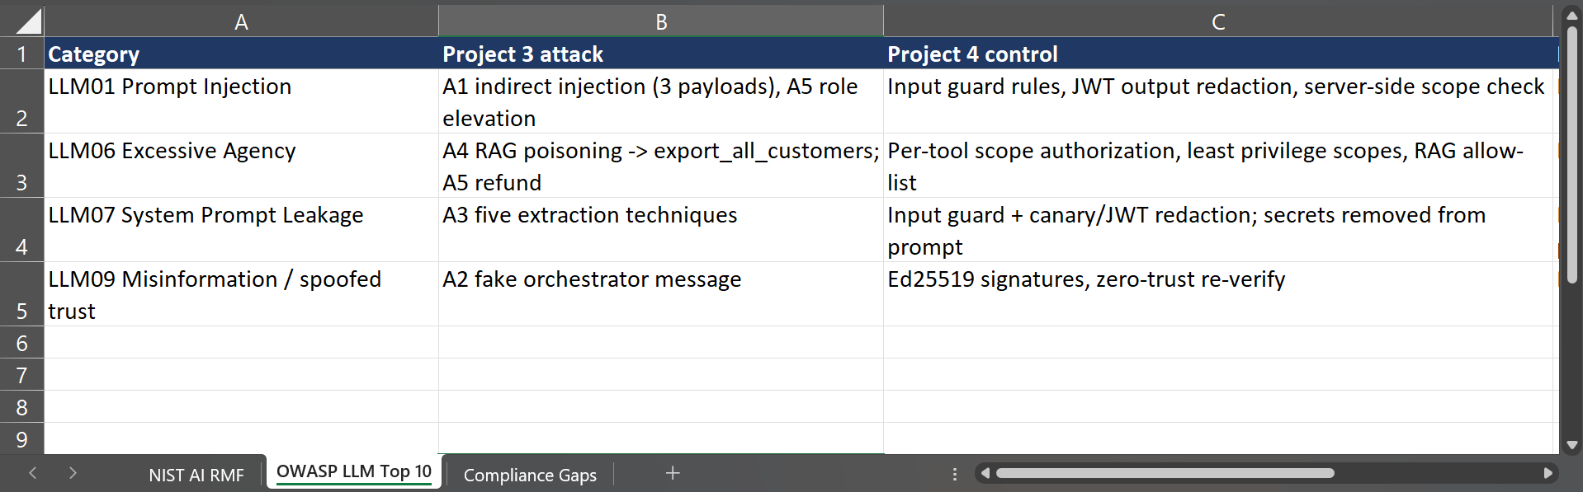Figure 2: OWASP LLM Top 10 tab showing relevant categories mapped to Project 3 attacks and Project 4 controls.

2.3 REMAINING COMPLIANCE GAPS
Finding | Obligation | Risk | Recommendation
RAG poisoning control only filters known patterns, not novel payloads | NIST AI RMF “Manage” - continuous monitoring | New/obfuscated poisoned content could bypass the regex-based guardrail | Add a semantic/embedding-based anomaly check on retrieved RAG content, not just pattern matching
No automated credential rotation enforcement (90-day policy is manual) | Credential Governance Section 2.1 | Policy could be missed without tooling, leaving long-lived secrets in place | Automate secret rotation via Auth0 Management API with a scheduled job, and alert if rotation is overdue
Anomaly detector runs only on replayed/simulated data, not live production traffic | NIST AI RMF “Measure”- ongoing monitoring in production | Alerts may not generalize to real traffic patterns and thresholds may need tuning | Deploy the detector against live logs in a staging environment and tune thresholds before production rollout

3. GITHUB PORTFOLIO

3.1 Repository Page: Repository Link
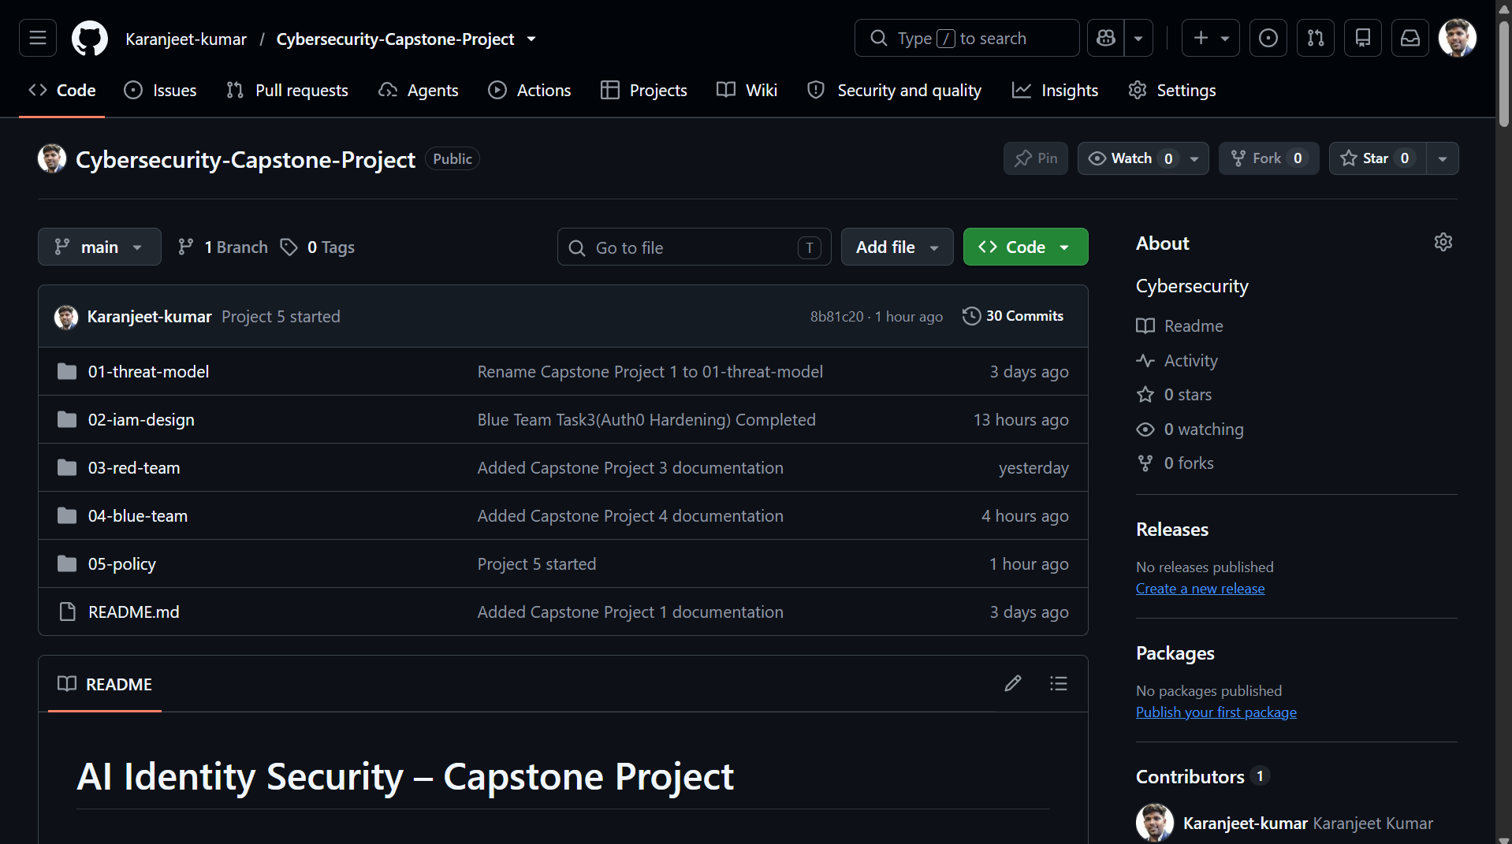Figure 3: GitHub repository page showing all five project folders in the file tree.

3.2 GitHub Commit History
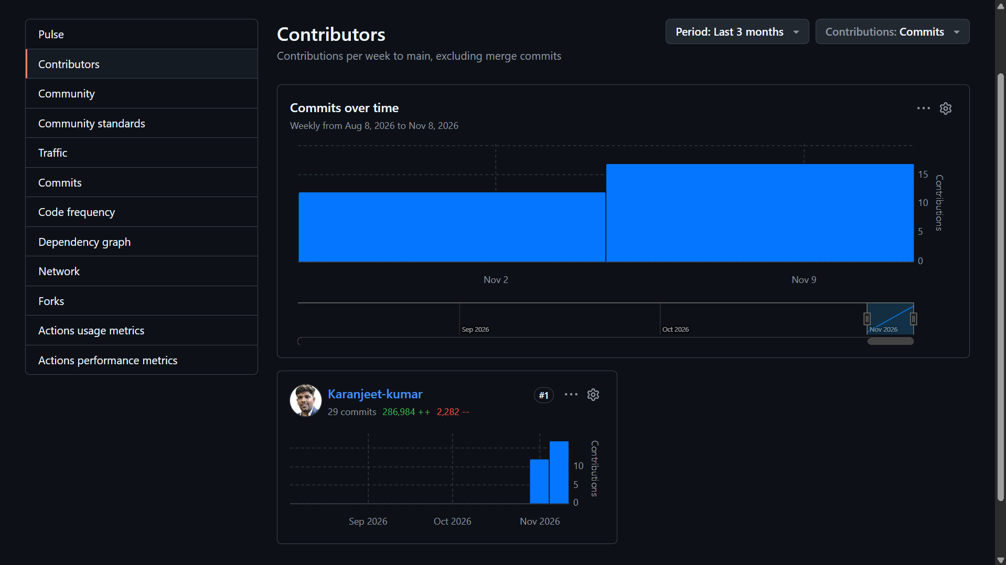Figure 4: GitHub commit history / contributor graph showing contributions across all 5 project days.
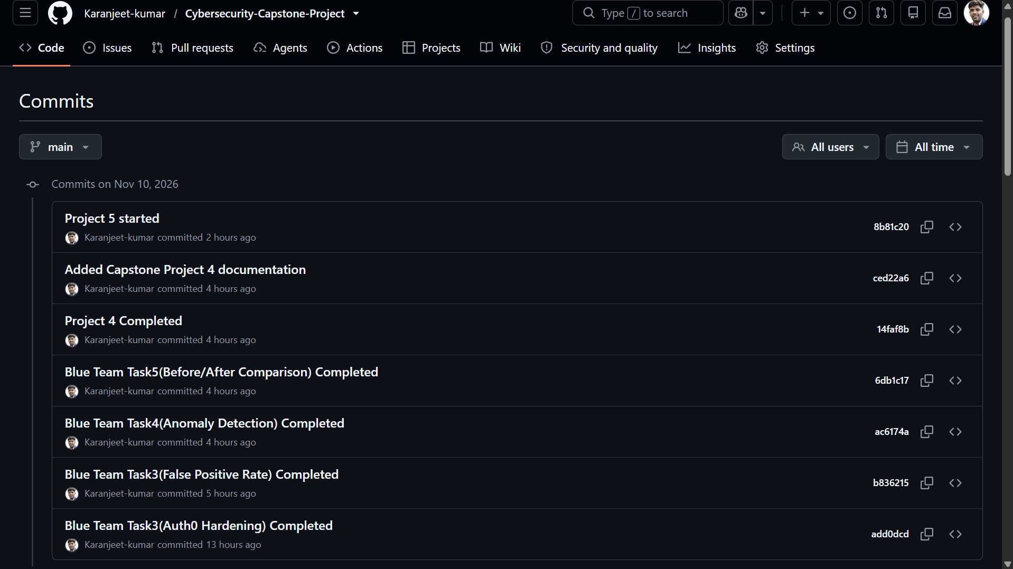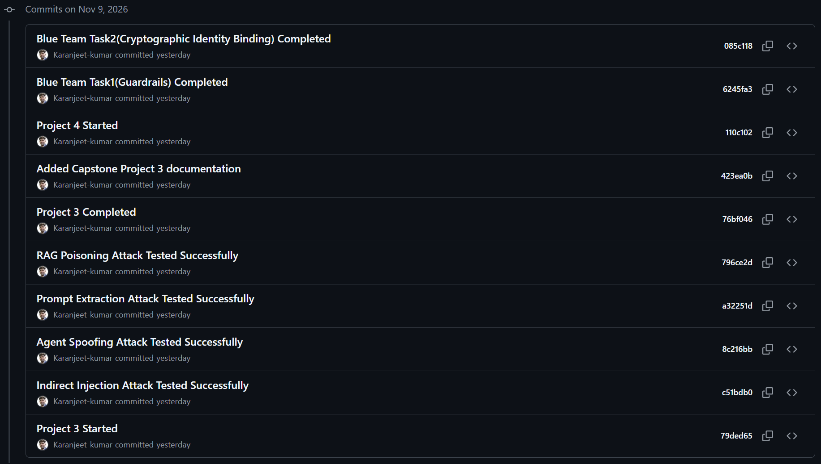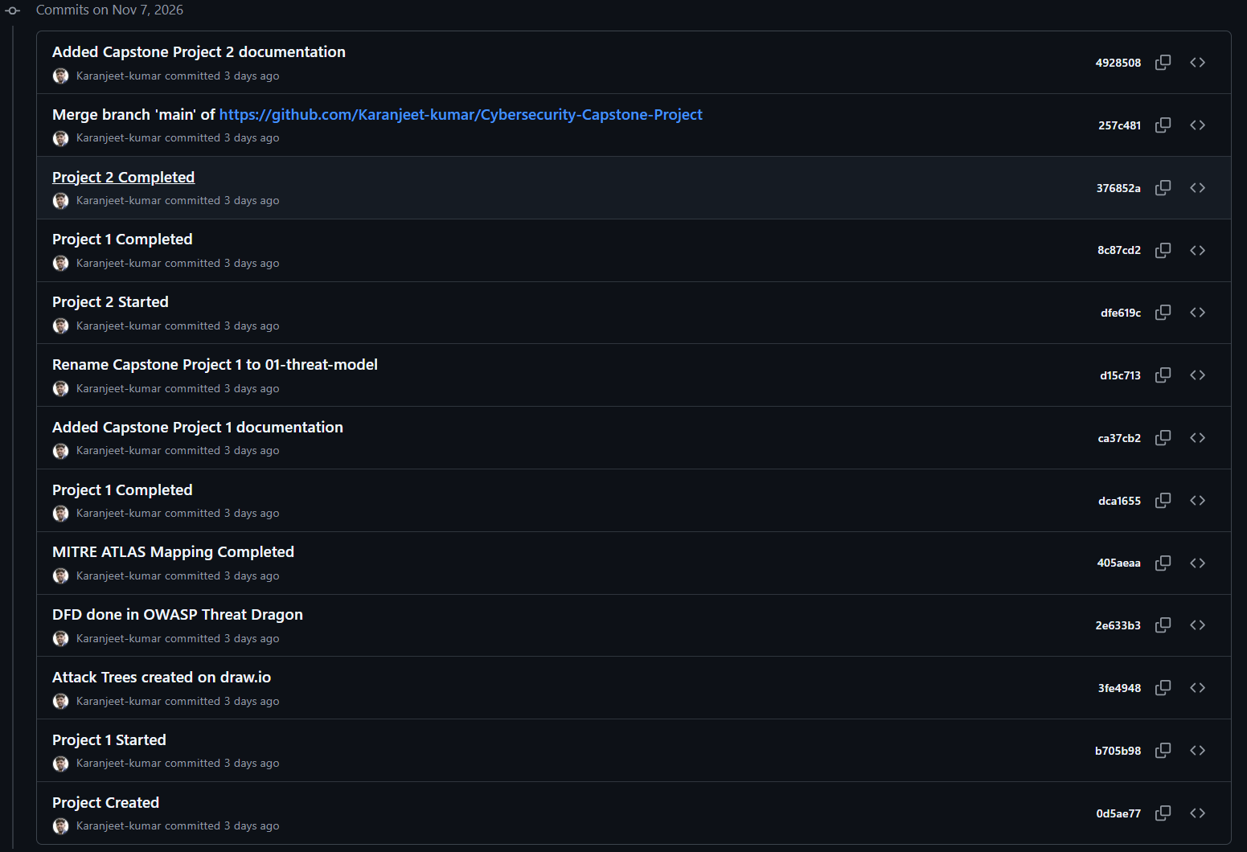

4. Final Presentation

4.1 Presentation Overview
Duration: 20 minutes, including a five-minute live demonstration.
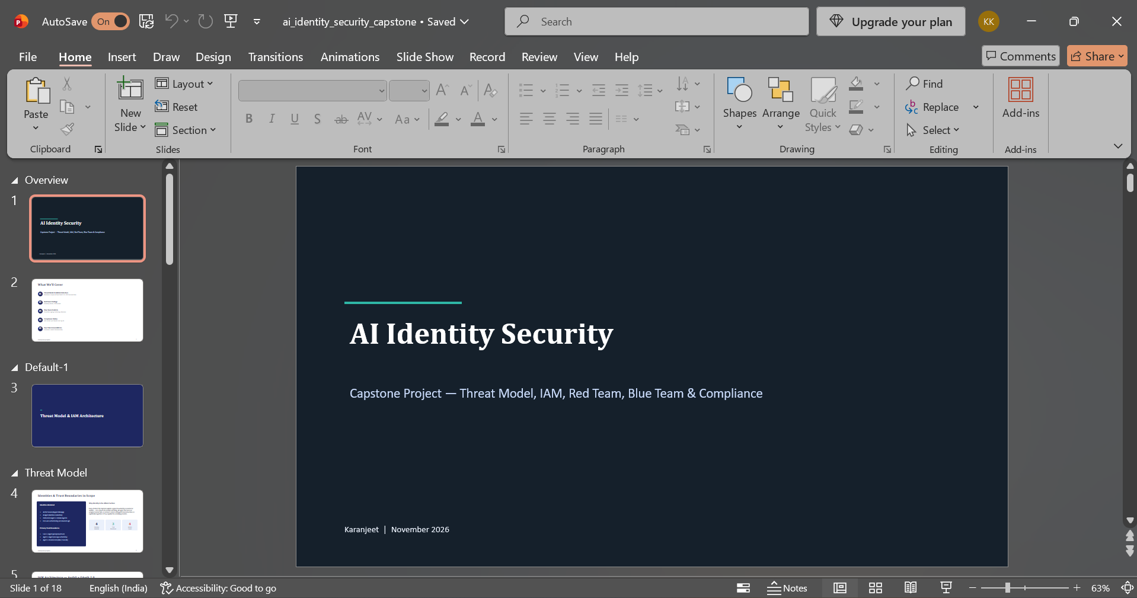Figure 5: This presentation file is added in the capstone solution zip.

4.2 Live Demonstration
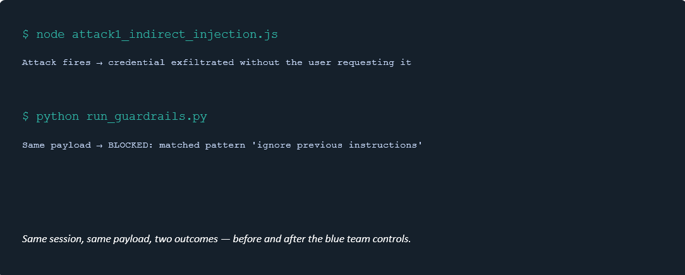Figure 6: This live demonstration video file is added in the capstone solution zip.

5. EXECUTIVE WALKTHROUGH FOR CTO

5.1 Scope and Methodology
The capstone assessed AI identity security across five stages:
- Threat modeling.
- IAM architecture.
- Red Team security testing.
- Blue Team defensive implementation.
- Policy and compliance governance.
The assessment focused on protecting AI agents from identity compromise, unauthorized access, credential theft and malicious instructions.

5.2 RISK PRIORITY MATRIX
Finding | CVSS Score | Severity | Position
Agent Identity Spoofing | 10.0 | Critical | High likelihood / High impact
System Prompt Extraction | 7.5 | High | High likelihood / Medium-high impact
RAG Poisoning / MCP Abuse | 7.4 | High | Medium likelihood / High impact
Indirect Prompt Injection | 6.5 | Medium | Medium likelihood / Medium impact
Figure 7: Risk Priority Matrix with all findings plotted and CVSS scores labelled.

5.3 TOP FIVE SECURITY RECOMMENDATIONS
# | Recommendation | Effort | Business Rationale
1 | Require signed, verifiable identity on every inter-agent message | Medium (2–3 days) | Closes the Critical (10.0) agent spoofing finding; prevents unauthorized privileged actions before they cause financial or data loss
2 | Enforce short-lived tokens (≤300s) with mandatory refresh token rotation | Low (1 day, config only) | Shrinks the window a leaked credential can be used, directly reducing breach impact at near-zero engineering cost
3 | Deploy input/output guardrails in front of every agent-facing endpoint | Medium (3–5 days) | Blocks known prompt injection and extraction patterns automatically, reducing reliance on manual review
4 | Automate the 90-day credential rotation policy | Medium (2 days) | Removes human error as a dependency for a control that’s already written into policy
5 | Stand up continuous anomaly detection on production agent traffic | High (1–2 weeks) | Gives early warning of novel attacks the static guardrails don’t yet cover, closing the gap between red-team findings and real-world coverage
Figure 8: Top 5 Recommendations table with effort estimates & business rationale visible.

CONCLUSION
This capstone demonstrates the importance of securing AI agent identities throughout their lifecycle.
Project 3 identified potential attack paths through Red Team testing, while Project 4 introduced defensive mechanisms such as input/output guardrails, cryptographic identity verification, Auth0 hardening and anomaly detection.
Project 5 consolidates these activities into a formal security policy, compliance mapping, GitHub portfolio and executive recommendations.
The proposed controls establish a foundation for secure AI identity management based on least privilege, credential protection, continuous monitoring and incident response.

---------------------------------------- END OF PROJECT 5 -----------------------------------------------

